Produktförslag

Product – Production Step | Water used for production step / water footprint of the final product | Environmental & Social Impacts of Water Usage | Country | Water Footprint/Capita per Year | Footprint falling outside the country
Jeans (Cotton Farming) | - 8,700m³/t cotton  - ca. 1000g cotton/Jeans → 8,700l  - Jeans total: 10,850l | - 50% of the water used for irrigation is taken from streams. This constant water withdrawal can result in dried out water bodies.  - 1/3 of the water evaporates before it reaches the cotton fields. Additionally, many of the irrigation systems work inefficiently which leads to more losses.  - A variety of pesticides are used in cotton production. Inefficient waste water treatment leads to an intoxication of local water bodies.  - At the moment, there is not an efficient regulation in place that can guarantee clean water. | Pakistan | 1,331m³ | 16,3%
Hamburger (Meat Production) | - 15,400l/kg beef  - ca. 150g/Burger  2,310l  - Burger total: 2.500l | - Grazing live stock and the cultivation of crops used for feedings release various residues in water bodies (e.g. nutrients or pesticides).  - Unregulated waste water management leads to an intoxication of water bodies. | Brazil | 2,027m³ | 9,2%
Mobile phones (Mining of ores) | - 1 microchip 30l | - Most important river is over-utilized and transfers from other rivers are needed.  - Ore extraction from below the water table: Negative effects on hydrology and ecosystems.  - Acid runoff of mine drainage water affects water quality and freshwater resource.  - Closed mines can pose long-term environmental liabilities as they must be pumped and treated indefinitely to prevent contamination of surface and ground water. | South Africa | 1,255m³ | 22%
Coffee (Plantation) | - 1 cup of coffee (125ml) 140l | - Intensive coffee monocultures lead to water over-exploitation and intensive fertilizer use.  - Excessive water use and droughts cause declining water tables. This increases irrigation costs and harvest losses.  - The extensive use of pesticides and fertilizers on coffee plantations, as well as waste produced during the processing of coffee beans, contaminates water- ways and causes serious environmental threats. | Vietnam | 1,058m³ | 6.5%
Consumption of Products |  |  | Sweden | 1,428m³ | 52.2%

Exempel faktablad
Vietnam - Coffee
Population | 93 million (15)  Coffee Production  - Provides a livelihood for around 2.6 million people (incl. 600,000 farmers)  - Highest yield and productivity worldwide (3.5t/ha)  - 2% of GDP through coffee exports
Population Growth | 1% (119)
Life Expectancy | 72.91 years (129)
Urban population | 31%
Rate of urbanization | 3.03%
Capital | Hanoi (2.9 million inhabitants)
HDI | 0.617 (Sweden: 0.898)
Government type | Communist state
Area | 331,210 km² (310,070 km² of land)
GDP | 358.9 billion USD (39)
GDP per capita  *Brackets indicate the ranking globally, e.g. Vietnam ranks 93rd with regards to national population. | 4,000 (168)

Global average: 1358 m³/year/capita
Problems related to water in Vietnam including pollution and falling water tables due to excessive usage. Agriculture uses water for irrigation and emits pesticide-contaminated water. The water situation in Vietnam is likely to deteriorate as climate change predictions indicate a decrease in precipitation and water availability.

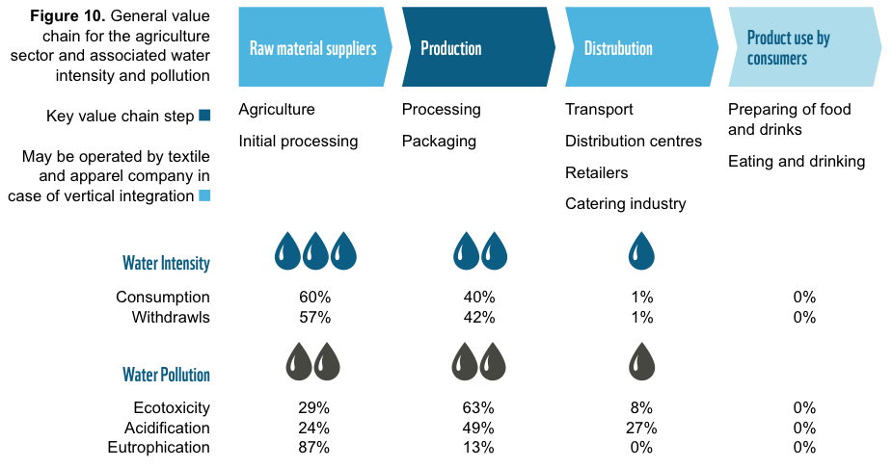

Sources: CIA Factbook (https://www.cia.gov/library/publications/the-world-factbook/geos/bg.html), Water Footprint Network (http://www.waterfootprint.org/?page=files/WaterFootprintLogo), WWF Germany (Wagnitz & Kraljevic, 2014).

